Types of JOINS in SQL Server
- INNER JOIN
- LEFT JOIN
- RIGHT JOIN
- FULL JOIN

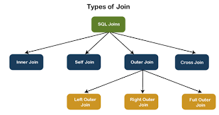

- INNER JOIN

This JOIN returns all records from multiple tables that satisfy the specified join condition. It is the simple and most popular form of join and assumes as a default join. If we omit the INNER keyword with the JOIN query, we will get the same output.
The following visual representation explains how INNER JOIN returns the matching records from table1 and table2:

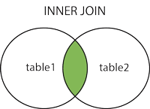
INNER JOIN Syntax
- SELECT columns
- FROM table1
- INNER JOIN table2 ON condition1
- INNER JOIN table3 ON condition2

INNER JOIN Example

- CREATE TABLE Student (
- id int PRIMARY KEY IDENTITY,
- admission_no varchar(45) NOT NULL,
- first_name varchar(45) NOT NULL,
- last_name varchar(45) NOT NULL,
- age int,
- city varchar(25) NOT NULL
- );

- CREATE TABLE Fee (
- admission_no varchar(45) NOT NULL,
- course varchar(45) NOT NULL,
- amount_paid int,
);

- SELF JOIN

A table is joined to itself using the SELF JOIN. It means that each table row is combined with itself and with every other table row. The SELF JOIN can be thought of as a JOIN of two copies of the same tables. We can do this with the help of table name aliases to assign a specific name to each table's instance. The table aliases enable us to use the table's temporary name that we are going to use in the query. It's a useful way to extract hierarchical data and comparing rows inside a single table.

SELF JOIN Syntax

- SELECT T1.col_name, T2.col_name...
- FROM table1 T1, table1 T2
- WHERE join_condition;
- SELF JOIN Example

- SELECT S1.first_name, S2.last_name, S2.city
- FROM Student S1, Student S2
- WHERE S1.id <> S2.iD AND S1.city = S2.city
- ORDER BY S2.city;

- CROSS JOIN

CROSS JOIN in SQL Server combines all of the possibilities of two or more tables and returns a result that includes every row from all contributing tables. It's also known as CARTESIAN JOIN because it produces the Cartesian product of all linked tables. The Cartesian product represents all rows present in the first table multiplied by all rows present in the second table.
The below visual representation illustrates the CROSS JOIN. It will give all the records from table1 and table2 where each row is the combination of rows of both tables:
CROSS JOIN Syntax
- SELECT column_lists
- FROM table1
- CROSS JOIN table2;

CROSS JOIN Example

- SELECT Student.admission_no, Student.first_name, Student.last_name, Fee.course, Fee.amount_paid
- FROM Student
- CROSS JOIN Fee
- WHERE Student.admission_no = Fee.admission_no;

- OUTER JOIN
OUTER JOIN in SQL Server returns all records from both tables that satisfy the join condition. In other words, this join will not return only the matching record but also return all unmatched rows from one or both tables.
We can categories the OUTER JOIN further into three types:
- LEFT OUTER JOIN
- RIGHT OUTER JOIN
- FULL OUTER JOIN

LEFT OUTER JOIN

The LEFT OUTER JOIN retrieves all the records from the left table and matching rows from the right table. It will return NULL when no matching record is found in the right side table. Since OUTER is an optional keyword, it is also known as LEFT JOIN.

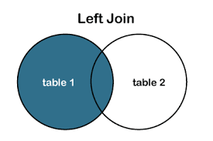
LEFT OUTER JOIN Syntax

- SELECT column_lists
- FROM table1
- LEFT [OUTER] JOIN table2
- ON table1.column = table2.column;

Example

- SELECT Student.admission_no, Student.first_name, Student.last_name, Fee.course, Fee.amount_paid
- FROM Student
- LEFT OUTER JOIN Fee
- ON Student.admission_no = Fee.admission_no;

RIGHT OUTER JOIN

The RIGHT OUTER JOIN retrieves all the records from the right-hand table and matched rows from the left-hand table. It will return NULL when no matching record is found in the left-hand table. Since OUTER is an optional keyword, it is also known as RIGHT JOIN.

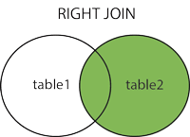

RIGHT OUTER JOIN Syntax

- SELECT column_lists
- FROM table1
- RIGHT [OUTER] JOIN table2
- ON table1.column = table2.column;

Example
- SELECT Student.admission_no, Student.first_name, Student.last_name, Fee.course, Fee.amount_paid
- FROM Student
- RIGHT OUTER JOIN Fee
- ON Student.admission_no = Fee.admission_no;

FULL OUTER JOIN
The FULL OUTER JOIN in SQL Server returns a result that includes all rows from both tables. The columns of the right-hand table return NULL when no matching records are found in the left-hand table. And if no matching records are found in the right-hand table, the left-hand table column returns NULL.
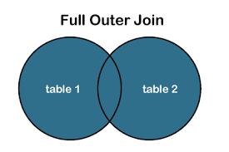
FULL OUTER JOIN Syntax
- SELECT column_lists
- FROM table1
- FULL [OUTER] JOIN table2
- ON table1.column = table2.column;

Example

- SELECT Student.admission_no, Student.first_name, Student.last_name, Fee.course, Fee.amount_paid
- FROM Student
- FULL OUTER JOIN Fee
- ON Student.admission_no = Fee.admission_no;

